TM

15% Off
Your Daily Essentials
Transform
Monthly NUTRITION


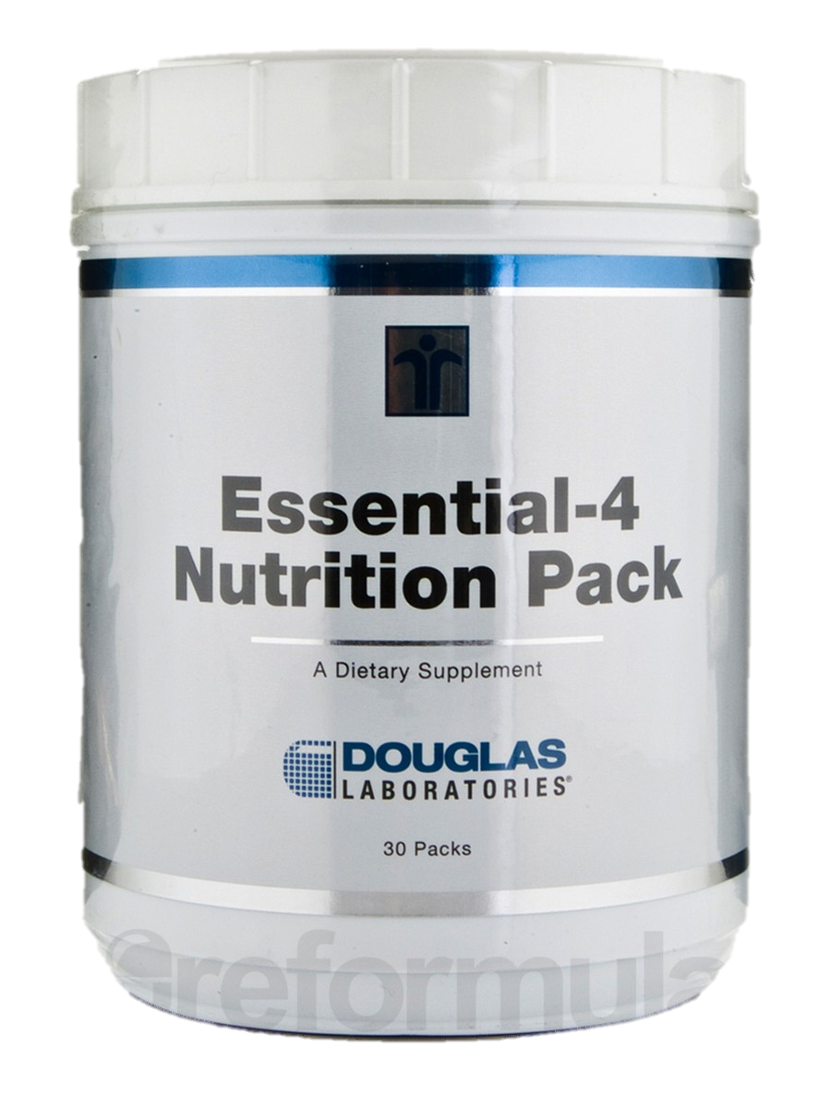
Multivitamins are very useful in helping you maintain overall good health. Unless you have healthy eating habits‚ you may not be acquiring essential nutrients in your diet. For example‚ you may not get the necessary nutrients in your daily diet if you don't eat certain fruits and vegetables‚ or avoid certain meats and grains. Even if you work hard‚ it may be hard to eat right all of the time‚ and you may need to take a multivitamin.
Essential-4 Nutrition Pack by Douglas Laboratories is a convenient supplement combines four of the most essential elements to support your health in a simple package. These four elements are multivitamins‚ essential fatty acids‚ probiotics‚ and coenzyme Q10 (CoQ10).

Each packet of Douglas Labs’ Essential-4 contains four supplements:
- Ultra Preventive X—similar to folic acid or vitamin D3‚ which offer
many health benefits.

- Opti-EPA—provides omega 3-fatty acids to support heart health
and boost brain power.

- Multi-Probiotic 4000—helps maintain and stabilize the intestinal
tract and digestive system by working to increase levels of
good bacteria and rid your body of bad bacteria.

- Citrus Solu-Q—a source of CoQ10‚ a powerful antioxidant.

Essential-4 Nutrition Pack also contains many other important nutrients
that help support vitality and a healthy lifestyle. When taken at the
recommended dosage of one packet per day with a meal‚ this package
provides a 30-day supply.
“Helping You To Create Energetic & Inspired Living By
Providing World- Class Chiropractic & Wellness Care
In All Dimensions Of Life.”

Health First Chiropractic / 11391-C Nuckols Road Glen Allen, VA 23059 / 804-270-6010 / www.hfcwellness.com

