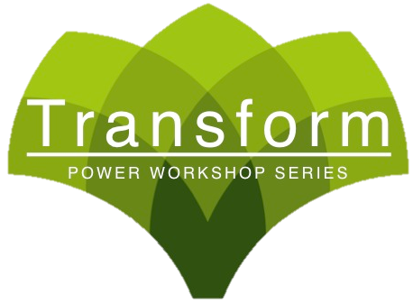
- LEARN HOW YOU CAN INCREASE YOUR IMMUNE SYSTEM IMMENSELY IN 5 MIN OR LESS!
- THESE SIMPLE INGREDIENTS TO YOUR DIET WILL EXPLODE YOUR ENERGY
- HOW YOUR DIET HAS A HUGE IMPACT ON YOUR HEALTH
- DISCOVER WHICH FOODS ARE BEST TO HELP YOU EXCEL IN YOUR WORKOUTS
- TRY OUT THE DOCS FAVORITE SUPERFOOD RECIPES!

Monday Feb 23rd 6:00-7:00pm
Limited Seating
Call To Reserve Your Seat!
###-###-####

Complimentary Workshop!
Super Living With Super Foods


