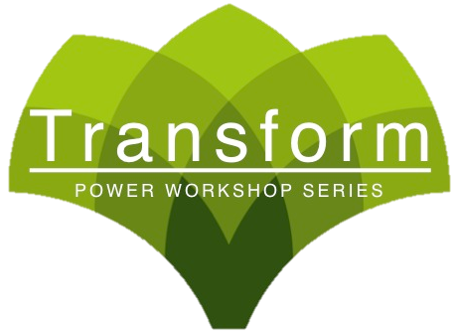
See Front Desk or Call To Reserve Your Seat!
804-270-6010
See Front Desk or Call To Reserve Your Seat!
804-270-6010
See Front Desk or Call To Reserve Your Seat!
804-270-6010
June 9th 6:00-7:00pm
- LEARN HOW YOU CAN INCREASE YOUR IMMUNE
- SYSTEM IMMENSELY IN 5 MIN OR LESS!
- THESE SIMPLE INGREDIENTS TO YOUR DIET WILL
- EXPLODE YOUR ENERGY
You’re Invited!
Address Here
“SUPER HEALTH WITH SUPERFOODS” WORKSHOP
¥¥
June 9th 6:00-7:00pm
- LEARN HOW YOU CAN INCREASE YOUR IMMUNE
- SYSTEM IMMENSELY IN 5 MIN OR LESS!
- THESE SIMPLE INGREDIENTS TO YOUR DIET WILL
- EXPLODE YOUR ENERGY
You’re Invited!
Address Here
“SUPER HEALTH WITH SUPERFOODS” WORKSHOP
¥¥
June 9th 6:00-7:00pm
- LEARN HOW YOU CAN INCREASE YOUR IMMUNE
- SYSTEM IMMENSELY IN 5 MIN OR LESS!
- THESE SIMPLE INGREDIENTS TO YOUR DIET WILL
- EXPLODE YOUR ENERGY
You’re Invited!
“SUPER HEALTH WITH SUPERFOODS” WORKSHOP
Address Here
¥¥

